Красноярская олимпиада школьников 2023-2024 учебный год
Школьный этап. Английский язык, 2 класс

LISTENING
Time: 10 minutes
Maximum points – 10
Task 1. Послушай диалог, напиши или выбери недостающую информацию.

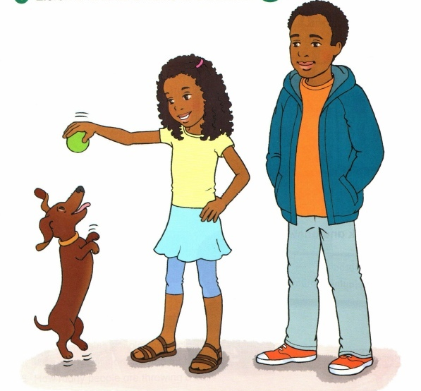
- What is the girl’s name?_________________
- How old is she?_______________________
- How many sisters has she got?__________________
- How many brothers has she got?__________________
- What is her sister’s name?
A Sue | BKate | CSusan

- What is her brother’s name?_________________

- How old is her brother?______________________
- Their dog is
A short | B long | C fat

- What colour is their dog?
A white | B black | C brown

- What’s their dog’s name?____________________

Не забудь перенести свои ответы в бланк ответов.

Красноярская олимпиада школьников 2023-2024 учебный год
Школьный этап. Английский язык, 2 класс
READING
Time: 15 minutes
Maximum points – 10
Task 1. Прочитай письмо и вставь пропущенные слова.
food, photo, from, pink, singer

Dear Jenny,
I’m 11 and I’m a student. I’m 1)_________ Oxford. After school, I’m in the choir. I’m a 2)___________.
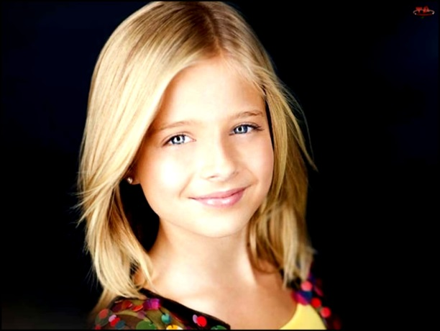
My favourite colour is 3)________ and my favourite 4)_______ is pizza. My favourite town is Liverpool. I’m a football fan! My hero is Michael Owen.
This is a 5)__________ of me.
Love from
Rachel

Task 2. Еще раз прочитай письмо и выбери правильный ответ.
- Is Rachel from Liverpool?
- Yes, she is. B) No, she isn’t.
- Is she 12?
- Yes, she is. B) No, she isn’t.
- Is her favourite colour blue?
А) Yes, it is. B) No, it isn’t.
- Does Rachel like pizza?
- Yes, she does. B) No, she doesn’t.
- Is she a football fan?
- Yes, she is. B) No, she isn’t.

Не забудь перенести свои ответы в бланк ответов.

Красноярская олимпиада школьников 2023-2024 учебный год
Школьный этап. Английский язык, 2 класс
USE OF ENGLISH
Time: 20 minutes
Maximum points – 20
Task 1. Прочти текст и вставь в пропуск пропущенное слово. Запиши.

got, has, is, he, a

This is Anna. She is little. She is five. Anna 1)____ got a cat. It is 2)______ big cat. This is Katrin. She is little, too. She is six. She has got a chick. It’s a nice chick. This 3)_______ Jackie. He isn’t little. 4)______ is big. He is nine. He has 5)______ a kitten. It is a funny little kitten.

Task 2. Составь предложения, расположив слова в нужном порядке, одно слово лишнее. Запиши.
- have, He, has, frogs. no, got, - _______________________
- has, have, got, I, three, cakes. - _________________________
- can, A, squirrel, tree, jump. - _____________________
- boy, have, got, has, That, two, ducks. - _______________
- a, This, are, goat. is, - _________________
- count, the, me, kittens. Give,-_________________________

Task 3. Прочитай вопросы, подбери к ним ответы. Запиши.

a monkey, a parrot, a cat, a bear

- What animal can drink milk?
- What animal can speak?
- What animal can sleep the whole winter?
- What animal can kiss?

Task 4. Прочитай тексты, сосчитай предметы и ответь на вопросы. Запиши.

- This boy has got one ball and that boy has got two balls. How many balls have the boys got?
- I have got four ducks and you have got seven ducklings. Ducks and ducklings have we got?
- The girl has got three books and the boy has got three books too. How many books have the girl and the boy got?
- The rat has got a hat and the bat has got a hat. How many hats have the rat and the bat got?
- The black dog has got five bones and the white dog has got seven bones. How many bones have the dogs got

Не забудь перенести свои ответы в бланк ответов.

